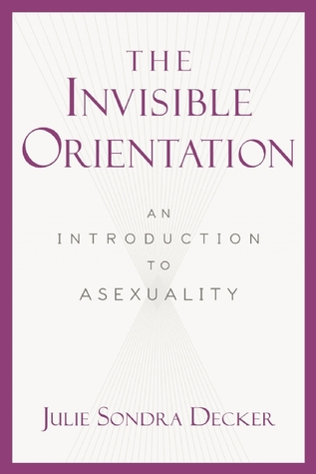

ADDITIONAL INFO:

**To contact the author for interviews, information, or appearance/event requests:**

Julie Sondra Decker / jsd@juliesondradecker.com / juliesondradecker.com  
PO Box 272595 / Tampa, FL 33688

**Author bios, photos, and additional info:**http://juliesondradecker.com/?page_id=2

**Autographed bookplates and electronic autographs for eBooks:**http://juliesondradecker.com/?page_id=2445

**Follow author’s social media:**  
Facebook: http://www.facebook.com/juliesondra  
Twitter: @JulieSondra

YouTube: http://youtube.com/juliesondra

Blog: http://juliesondradecker.blogspot.com  
Goodreads: https://www.goodreads.com/juliesondra  
Amazon Author Central: http://amazon.com/author/juliesondradecker

Bookstore and Library Sales:

**Perseus Distribution**210 American Drive

Jackson, TN 38301  
P: (800) 343-4499

F: (800) 351-5073

orderentry@perseusbooks.com

Published By:  
**Carrel Books (an imprint of Skyhorse Publishing, Inc.)**307 West 36th Street, 11th Floor

New York, NY 10018

Publicist: Lauren Burnstein  
(212) 643-6816 x 226

lburnstein@skyhorsepublishing.com

THE INVISIBLE ORIENTATION outlines what asexuality is, counters misconceptions, provides resources, and puts asexual people’s experiences in context as they move through a very sexualized world. It includes information for asexual people to help understand their orientation and what it means for their relationships, as well as tips and facts for those who want to understand their asexual friends and loved ones.

**HARDCOVER:** ISBN-10: 1631440020 / ISBN-13: 978-1631440021

**AUDIO:** ASIN: B00MR9SJJG

**KINDLE:** ASIN: **B00MSYUXOO**

**Retailers: Amazon ∙ Audible ∙ Barnes & Noble ∙ Book Depository ∙   
Books-A-Million ∙ IndieBound ∙ Powell's**

**THE INVISIBLE ORIENTATION: AN INTRODUCTION TO ASEXUALITY JULIE SONDRA DECKER**  **∙ juliesondradecker.com  
SKYHORSE PUBLISHING / CARREL BOOKS / © 2014**